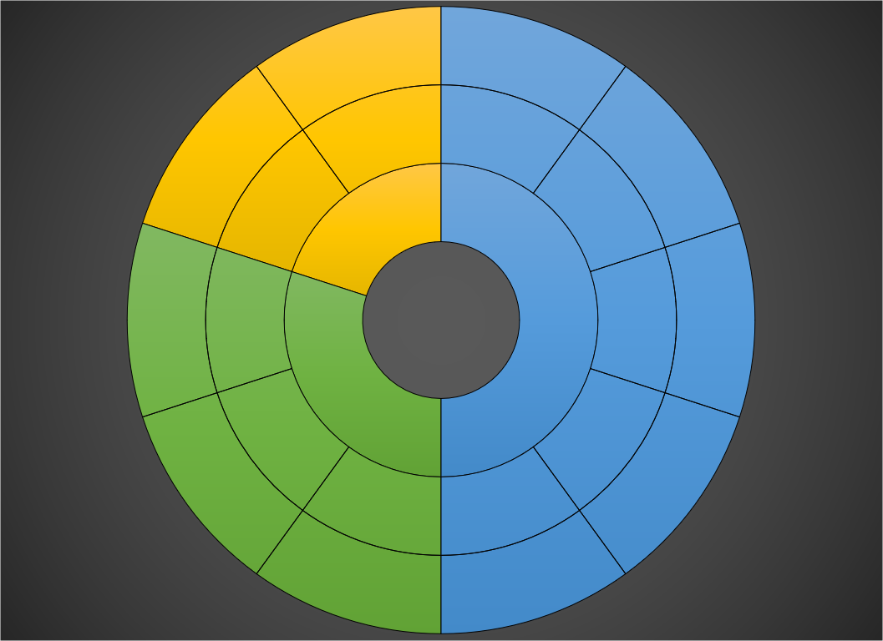

**BACKEND**

**FRONTED**

**DATA ANALYSIS**

**MORTALITY RATE ANALYSIS**